Nagrada večernica

21. nagrado večernica je prejel prejel Peter Svetina za pesniško zbirko Molitvice s stopnic.

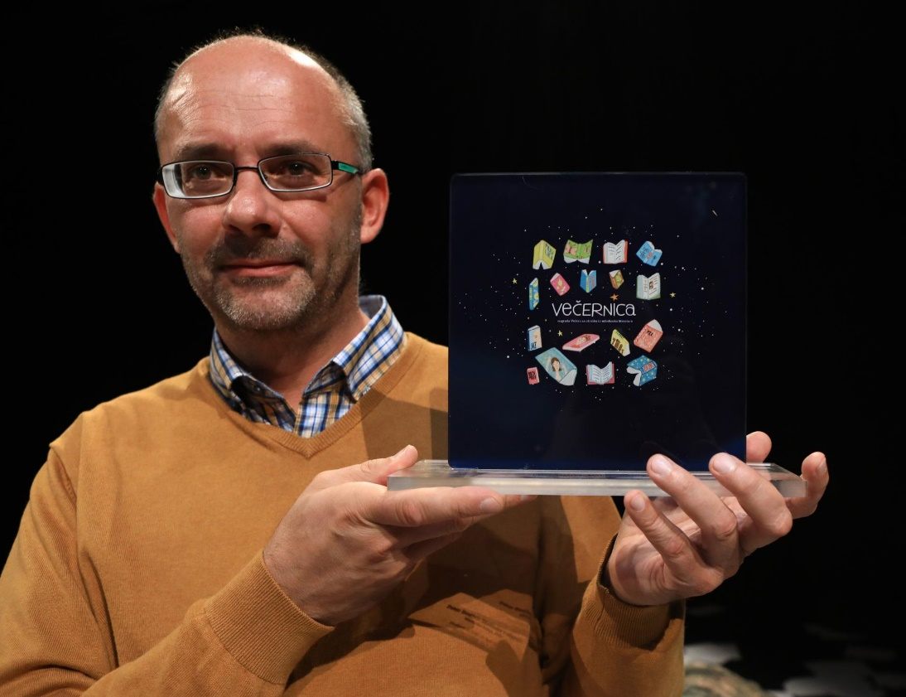
https://www.google.si/url?sa=i&rct=j&q=&esrc=s&source=images&cd=&cad=rja&uact=8&ved=0ahUKEwjlu--OscrWAhVEXRQKHRu_BiwQjhwIBQ&url=https%3A%2F%2Fwww.vecer.com%2Fpeter-svetina-tistim-ki-so-jih-hvalili-smo-rekli-piflar-6313180&psig=AFQjCNFXlozrOl5ZWh1L4hJUxcvSTG8Nfg&ust=1506774098115607 [29. 9. 2017][14:25]
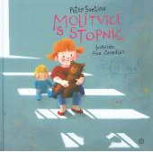
https://www.google.si/url?sa=i&rct=j&q=&esrc=s&source=images&cd=&cad=rja&uact=8&ved=0ahUKEwiP3rSLssrWAhVKWhQKHc0BDmgQjhwIBQ&url=http%3A%2F%2Fwww.bukla.si%2F%3Faction%3Dbooks%26book_id%3D25967&psig=AFQjCNEt9hqL-zgzeiZzBlGmIY5AHNfHdQ&ust=1506774356480817 [29. 9. 2017][14:27]

